Credit Card Authorization Form

I, ___________________________________________, hereby authorize Delivery Limited, Inc. to charge my credit card account in the event that any invoices remain unpaid for more than 45 days past the original due date.* I understand that any invoices under dispute are not subject to the 45-day time period.

Credit Card Number: ______________________________ Expiration Date: ______ / ______

3-Digit VISA or MasterCard CVC Code: ________ 4-Digit AmEx CVC Code: ________
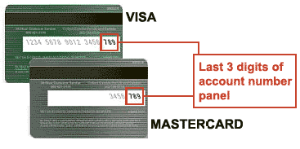
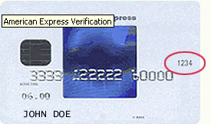

Credit Card Billing Address:

Street: _____________________________________________________
City, State Zip: ______________________________________________
Country (if not U.S.): _________________________________________
Telephone: ( ) ______ - ___________

______________________________________ ____/____/______
Cardholder’s Signature Date

OPTIONAL: Sign and date here only if you wish for our accounting department to keep your credit card information on file:

As the credit card holder, I also authorize Delivery Limited, Inc. to charge my credit card for future purchases verbally approved by me.

Sign Here: ________________________________ Date: __________________

* A 3.25% convenience fee will be assessed for payments by credit card that are $3,000.00 or greater.

Your completion of this authorization form helps us to protect you, our valued client, from credit card fraud.

Delivery Limited, Inc. will keep all information entered on this form strictly confidential.
Please return this form via email to coby.asaff@deliverylimited.com or via fax to (214) 261-1001.

